Using the New Viper Route Generator (VRG) Application

The new VRG application has several features that will make configuring the Viper in router mode simpler. The VRG now has the ability to save a project and then re-open that project for further modification. Using the VRG is somewhat straight forward and intuitive. The user must get familiar with creating Viper template files and how to use the Viper Tool (another CalAmp application) to import the VRG generated configuration files in to a Viper.

The user should install the VRG application on a Windows 7 or later machine. The VRG is a VB dotnet app so it should run on any Windows based PC.

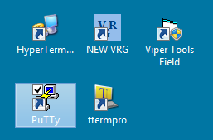

New VRG Application

It would be helpful to the user if they also became familiar with a couple of non-CalAmp applications such as HyperTerminal, PuTTy and TeraTerm. These apps will be useful to the user from time to time if they every have a need to access a Viper through the Viper’s Setup port and not through the Viper’s LAN Ethernet port.

The user needs to create a VRG Viper Project folder to store the Viper’s configuration files that the VRG will create. These folder can be named anything the user is comfortable with. In this Example VRG_Projects will be used as the name of the project folder.

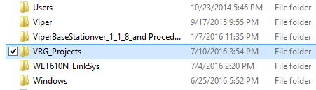

Create a Project Folder to Store Viper Configuration files to

Viper configuration template files should be created so that they can be used by the VRG to copy all common operating parameters to all the configuration files that will be generated by the VRG, such as transmit and receive frequencies, bandwidth, data rate, etc… These common Viper operating parameters will typically be the same in all Viper configurations for the same Viper project network (same frequencies). Several special CalAmp documents (Creating Viper Template Files) has been created to help the user generate the basic template files to be used with both the old and new VRG app. Please refer to those documents before proceeding with this document. In most cases the user should try to use Viper firmware version 3.8 or later for all template files when using the new VRG. The template files should be stored in the VRG_Project folder created earlier.

Once the templates files have been created the user can now startup the new VRG application. The home screen should be displayed as shown below.

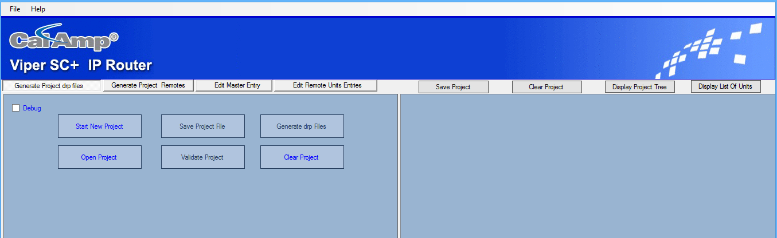

New VRG Home Screen

The user will have the option of starting a new VRG project or opening a previous VRG project (only if the created with the New VRG application). To start a new VRG project click the Start New Project button. The new screen will be populated as shown below.

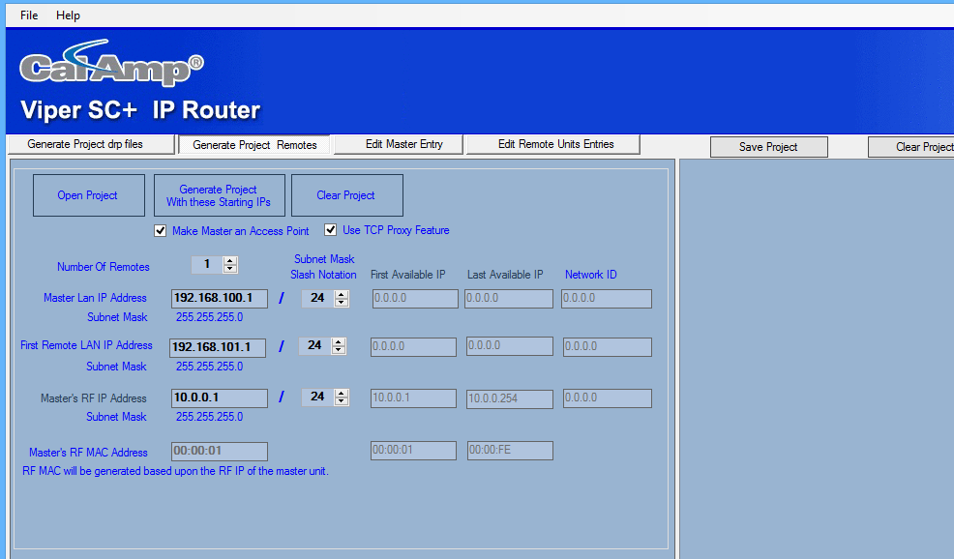

Select how many remotes will be in project

The user will be allowed to choose the number of remotes that will be in a project. The user should always try to allow for future expansion of the number of remotes by 20%. In this example we have selected 10 remotes.

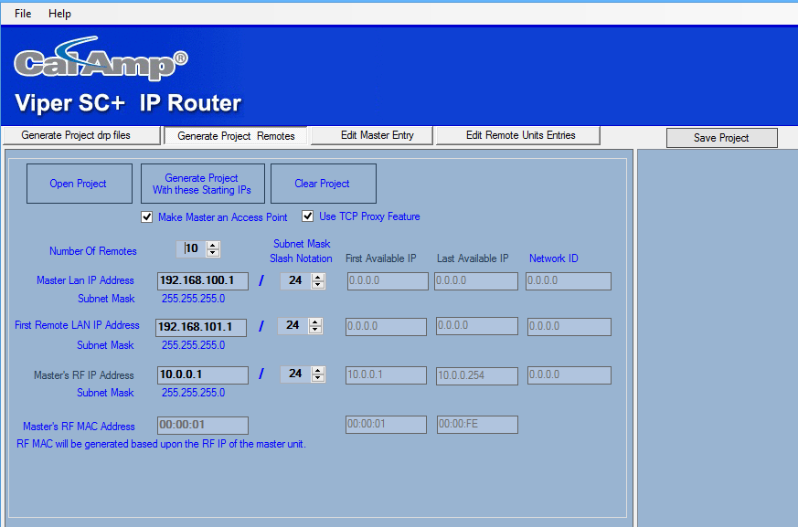

Select the number of remotes

To start the project IP addressing the user can enter some base line IP address to start the project with. The user should then click on Generate Project button to use the IP addressing scheme entered. The user will be allowed to modify each Viper’s LAN and RF IP addresses once the project has been started.

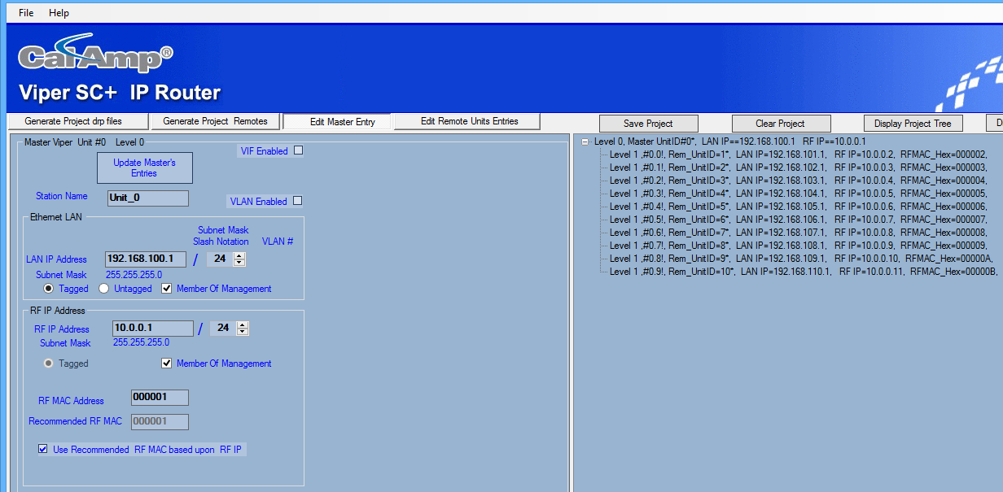

Select any remote on the right-hand panel to edit

The user can also modify the Virtual Interface (VIF) IP addresses and the VLAN IDs by checking the check boxes for each feature. Most project the VIF and VLAN features will not be used.

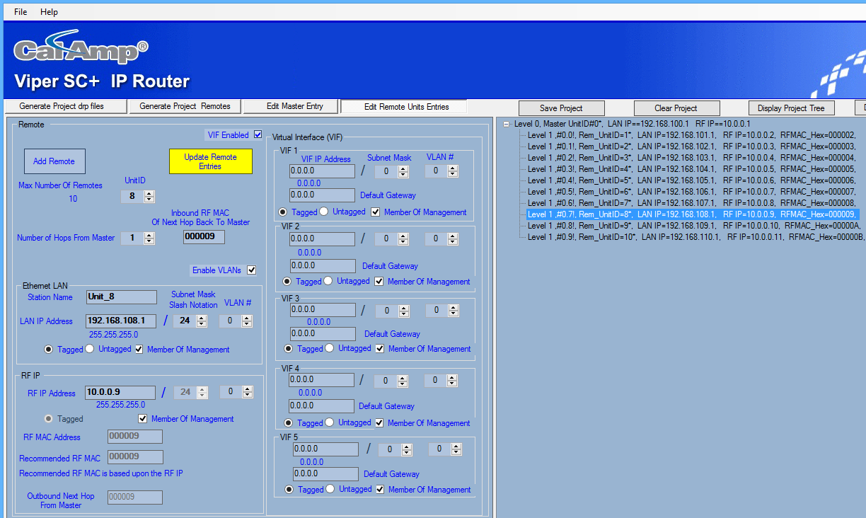

Select a remote to modify

In this example all the remotes will only be one hop away from the master Viper. In the right-hand panel you will notice that the master is at Level 0 and all the remotes are at Level 1 (one hop away or direct report to the master). Later in this procedure it will be detailed on how to modify Vipers so that they are two hops away from the master. Always ensure to click on the Update Remote Entries to save the modified parameters or the modify parameters will not be saved. The user should ensure they modify the Station Name with a descriptive name. ***This name will also appear in the file name for that remote to make it easier to match the Viper configuration file to the correct remote.***

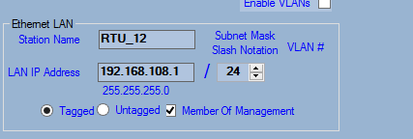

Modify Station Name: This will be included in the configuration file name

The user is no longer restricted to sequential IP addressing for the LAN IPs, however there are certain rules that must be followed for a Viper project.

1. All Vipers must have a unique LAN IP address.
2. All Vipers must be on the same RF subnet ID.
3. Any Viper IP address must always be unique.
4. Any Viper IP address must be on a different subnet ID (except the RF IP).
5. All RFMAC addresses must be unique in the project.

Once all the new IP addresses have modified, the user can now save the Project by clicking on the Save button. The user will be prompted to save to a known folder location. The user can select any folder. In this example the folder will be the previously created VRG_Projects folder.

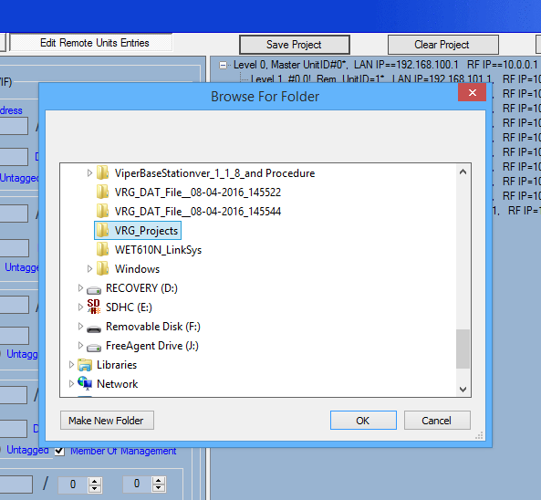

VRG_Projects Folder

The user will next be prompted to select a file name for the project. CalAmp recommends using a descriptive name such as the tower site name but it has to be a Windows accepted file name convention.

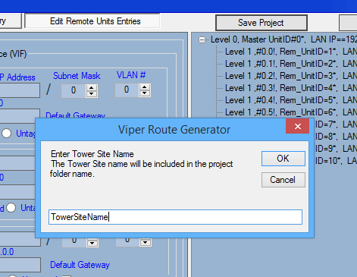

Any descriptive name can be used (as long it’s a valid Window file name)

The project folder now contains the save project as a VRG dat file. This file should not be edited even though it is saved as a text file. Errors will occur if the saved VRG project dat file is edited in any way and will not be able to be recovered. The file name will also contain the date and time so the user will always have an unique file name and also make it easier to keep track of the files that are generated. Once the file has been saved off to the user’s PC, the user can now clear the project if desired by clicking on the Clear Project button.

To re-open the saved project after it has been cleared just click on the Open Project button and browse to the desired project folder and select the VRG_Project dat file you want to work with.

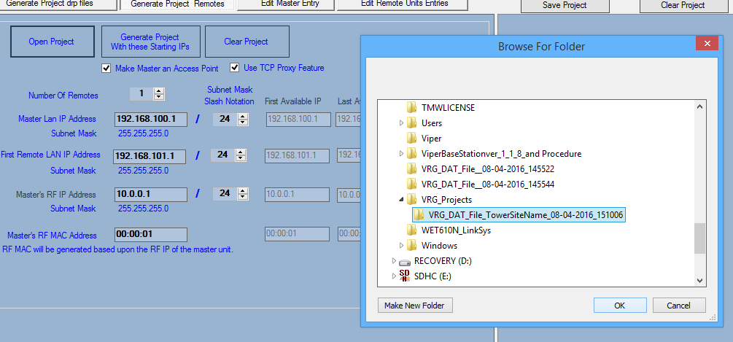

Browse to the VRG Project folder

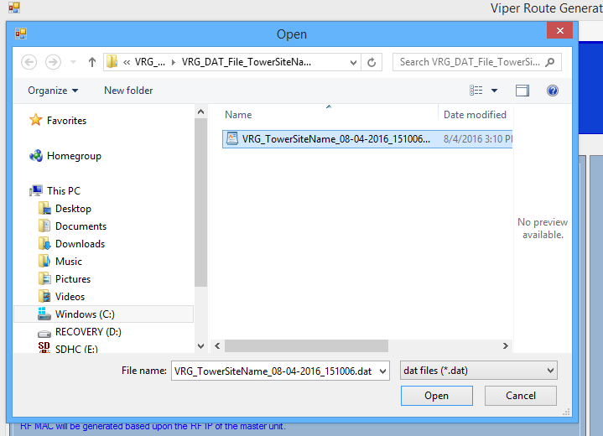

Click on the desired VRG dat file to open

When the user has modified all the remotes and is satisfied with the IP addressing scheme, they can now generate the Viper configuration files.

The user must click on the Generate Project drp files button to navigate to the home scree to start the process.

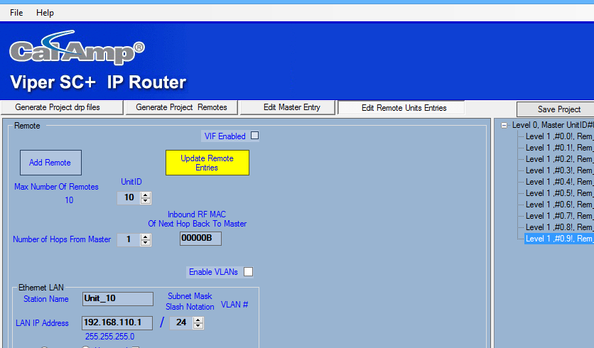

Click on Generate Project drp files

The user must save the project again to ensure it has been saved to enable the Validate Project button.

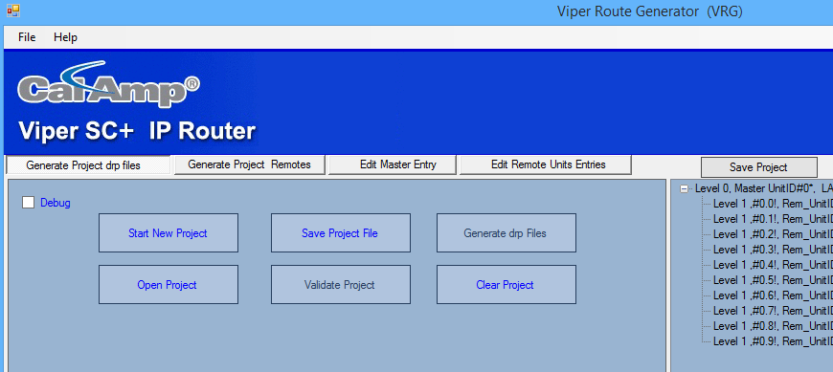

First Click on Save Project File, then Validate Project and finally Generate drp files button

The Validate Project button only does some limited error checking on the IP addressing scheme. The user should double check the rules for the IP addressing scheme detailed earlier in this procedure. ***CalAmp strongly recommends not to relying on the Validate Project feature to verify their project as being validated 100% with no IP addressing issues.*** If the user can proceed to Generate drp files if the Validate feature doesn’t return an error. If there is an error, the error must be corrected before the Generate drp files button becomes enabled.

The next step is to click on the Generate drp files button. The user will be prompted to enter the Tower Site Name to be included for each Viper drp configuration file with the time and date.

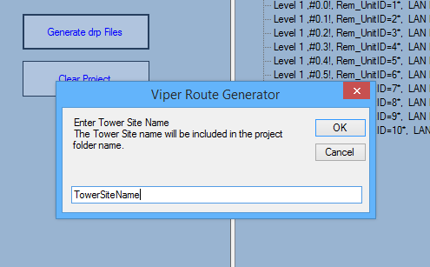

Next the user will be prompted to choose one or two frequency project. The default is a single frequency project. Most projects will be a single frequency but there are some 900 MHz project that will require a two frequency project. In a two frequency project the remotes will have the transmitter and receiver frequencies swapped to ensure they can communicate with the master. If there is a Relay Point in the project then all the Level 2 Vipers will flip the frequencies again.

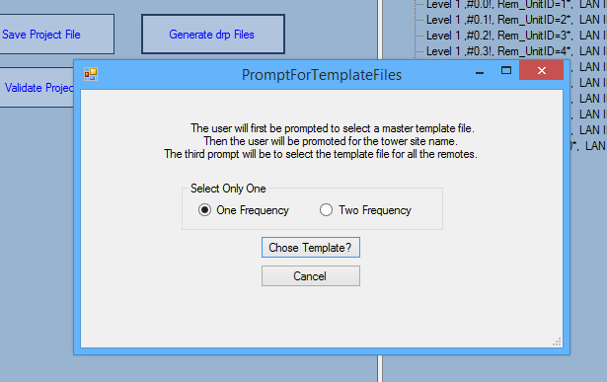

Click on Choose Template

The user is prompted to choose a template file that will be used in the master Viper first. Browse to where the template files are stored for this project.

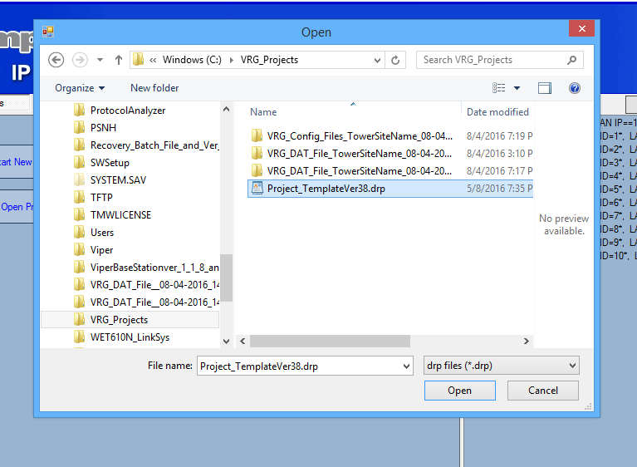

Open the template file to be used for the master Viper

Sometimes projects requires two template files, one for the master and one for the remotes. Refer to the Creating Template documents for details between one or two templates. The VRG application will inspect the template file to determine which Viper firmware version the template file was created with.

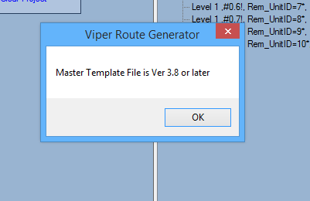

VRG checks to determine which Viper firmware versing the template file was created with

The VRG application will next prompt the user for the template file to be used for all the remotes (All the remotes must use the same template file, individual template files for the remotes are not allowed in the new VRG). Browse to the location where the remote template is stored.

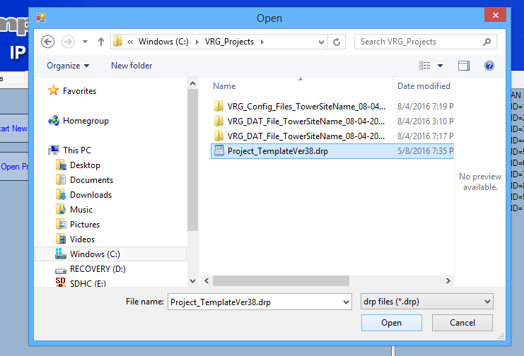

Select the remote template file.

Again the VRG will inspect the template to determine version used to create the template file.

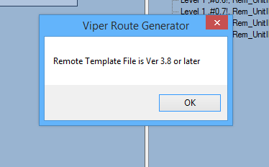

Remote Template version determine

This completes the procedure in generating the viper configuration files. Browse to the folder where the files are located and verify that a new folder was created containing all the Viper’s configuration files.

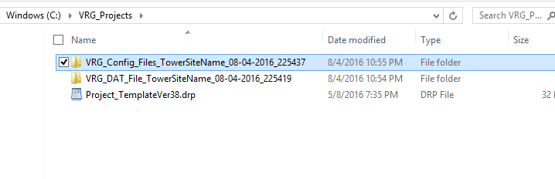

Project Folder with both Dat and Configuration folder

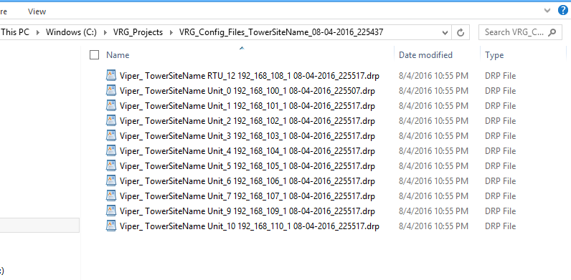

All the configuration files, notice the RTU_12 Station Name is included in the file name.

These drp files can now be loaded into each Viper. Please refer to the Using Viper Tool document to download a configuration file into a Viper using the Viper Tool.

In the above example all the remotes were one hop away from the master. However a lot of projects will require some of the remotes to pass through a Relay Point to get back to the master which would be two hops away. The user can click on the remote to modify then select two hops from the master. The user must then select the RFMAC address that the remote will pass through (the Relay Point) on its way back to the master. In the example below Unit 8 will be two hops away from the master and will pass through the RFMAC 000003 which is Unit 2.

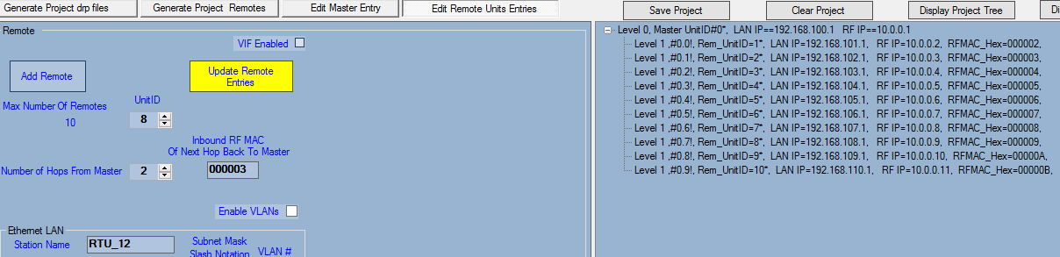

Unit 8 will be two hops away from the master and use RFMAC 000003 (Unit 2) as the Relay Point

Ensure you click the Update Remote Entries to save and implement changes.

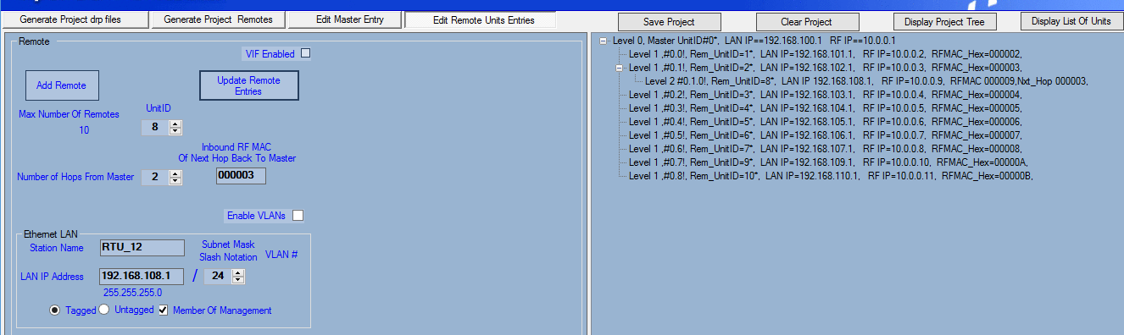

Unit 8 now must pass through Unit 2 to get back to the master.

This release of the New VRG only allows for two hops. Three and four hops will be available in the future release of the New VRG application.

The Display List of Units is a helpful way of finding remotes once they have been modified and may no longer be in a sequential IP address scheme.

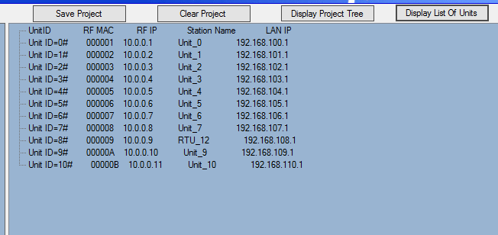

Display List of Units

The Display Project Tree button will display the project back as a tree type display.

This completes the tutorial of the New VRG application.